**Code Hacks**

**JAVA**

**-IMPORTS-** (HOT-COPIES)

import org.springframework.web.bind.annotation.RequestMapping;

import org.springframework.web.bind.annotation.RequestMethod;

import org.springframework.web.bind.annotation.RequestParam;

import org.springframework.web.servlet.mvc.support.RedirectAttributes;

import org.springframework.stereotype.Controller;

import org.springframework.ui.Model;

import javax.persistence.GeneratedValue;

import javax.persistence.GenerationType;

import javax.servlet.http.HttpSession;

import javax.persistence.Column;

import javax.persistence.Entity;

import javax.persistence.Table;

import java.util.Date;

import javax.persistence.Id;

import java.util.Date;

**-JSP file -**

<%@ **taglib** prefix = *"c"* uri = *"http://java.sun.com/jsp/jstl/core"* %>

<%@ **taglib** prefix=*"form"* uri=*"http://www.springframework.org/tags/form"*%>

**-APPLICATION.PROPERTIES-**

spring.mvc.view.prefix=/WEB-INF/

(WHEN CONNECTING TO DATABSE)

spring.datasource.url=jdbc:mysql://localhost:3306/<<YOUR_SCHEMA>>

spring.datasource.username=<<dbuser>>

spring.datasource.password=<<dbpassword>>

spring.datasource.driver-class-name=com.mysql.jdbc.Driver

spring.jpa.hibernate.ddl-auto=update

**-CSS/BOOTSRAP-**

<link href="https://cdn.jsdelivr.net/npm/bootstrap@5.0.0-beta1/dist/css/bootstrap.min.css" rel="stylesheet" integrity="sha384-giJF6kkoqNQ00vy+HMDP7azOuL0xtbfIcaT9wjKHr8RbDVddVHyTfAAsrekwKmP1" crossorigin="anonymous">

Goes at bottom of boddy (script tags)

<script src="https://cdn.jsdelivr.net/npm/@popperjs/core@2.5.4/dist/umd/popper.min.js" integrity="sha384-q2kxQ16AaE6UbzuKqyBE9/u/KzioAlnx2maXQHiDX9d4/zp8Ok3f+M7DPm+Ib6IU" crossorigin="anonymous"></script>

<script src="https://cdn.jsdelivr.net/npm/bootstrap@5.0.0-beta1/dist/js/bootstrap.min.js" integrity="sha384-pQQkAEnwaBkjpqZ8RU1fF1AKtTcHJwFl3pblpTlHXybJjHpMYo79HY3hIi4NKxyj" crossorigin="anonymous"></script>

**-DEPENDENCIES-**

Spring Boot Spring Data JPA starter (JPA)

Java Mysql Connector (MySQL)

Tomcat-ember-jasper

javax.servlets (jstl)

spring-boot-starter-validations

(NOTE: Some occasionally need to be manually put in POM.XML)

<dependency>

<groupId>org.springframework.boot</groupId>

<artifactId>spring-boot-starter-validation</artifactId>

</dependency>

<dependency>

<groupId>org.apache.tomcat.embed</groupId>

<artifactId>tomcat-embed-jasper</artifactId>

</dependency>

**BOOTSTRAP GRID STARTER**

<div class=*"container"*>

<div class=*"row"*>

<div class=*"col-sm"*>

</div>

</div>

</div>

Controller Packege = Routes

Repository Package = Handles CRUD

Service Package =

**Spring Starter Project – Set-Up**

#1: Start a new project in Spring Tool Suite

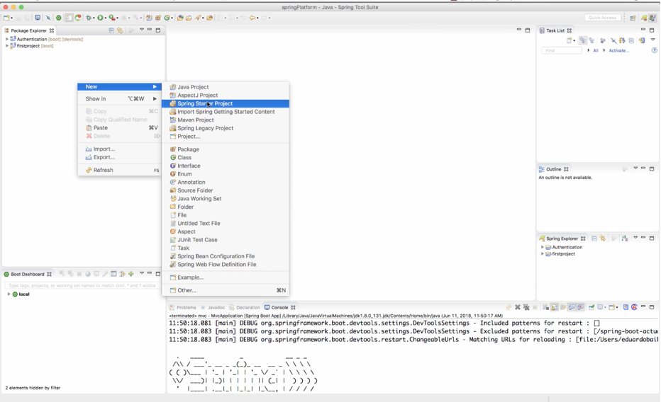

#2: Fill in the fields like below.

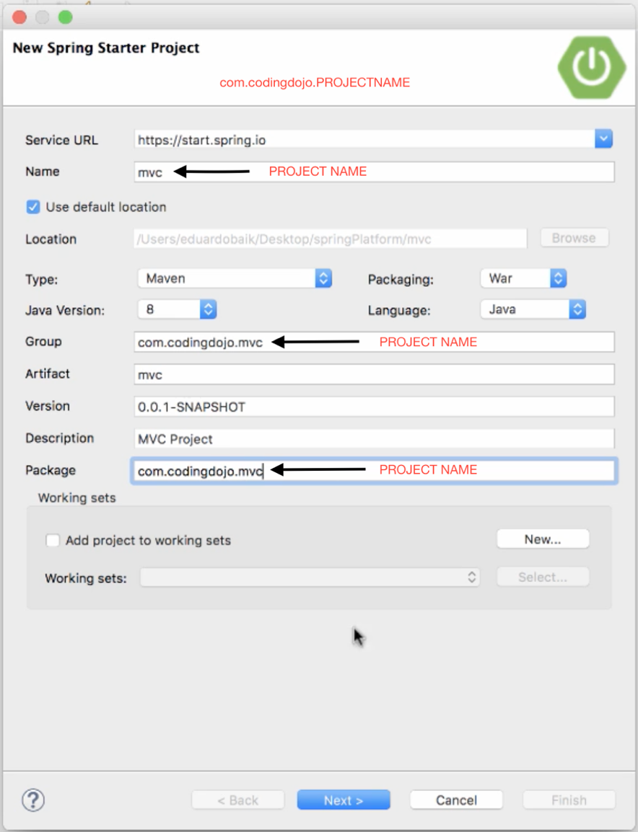

#3: Add all these Dependencies below

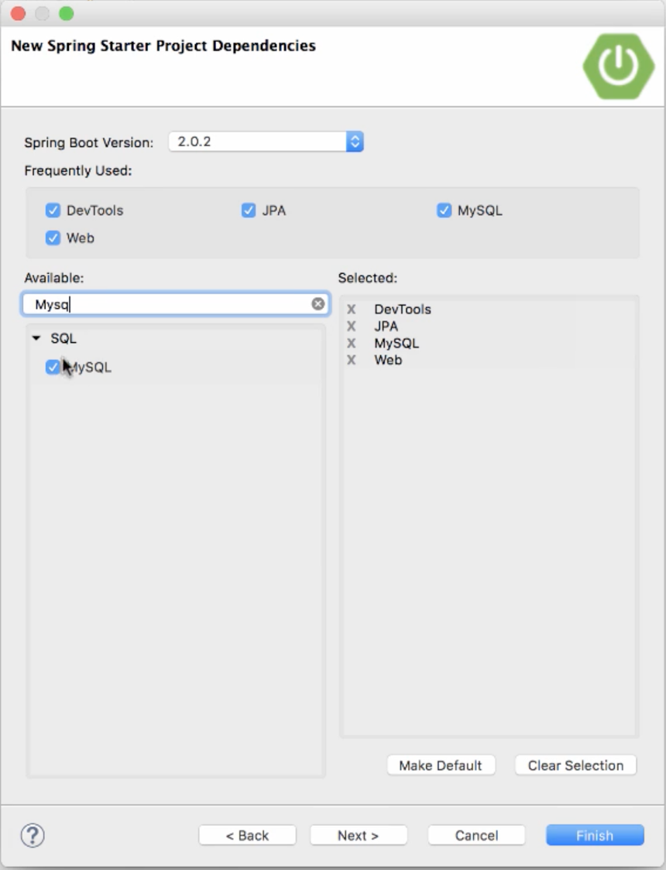

#4: Configure the app to connect to our data source with the following below.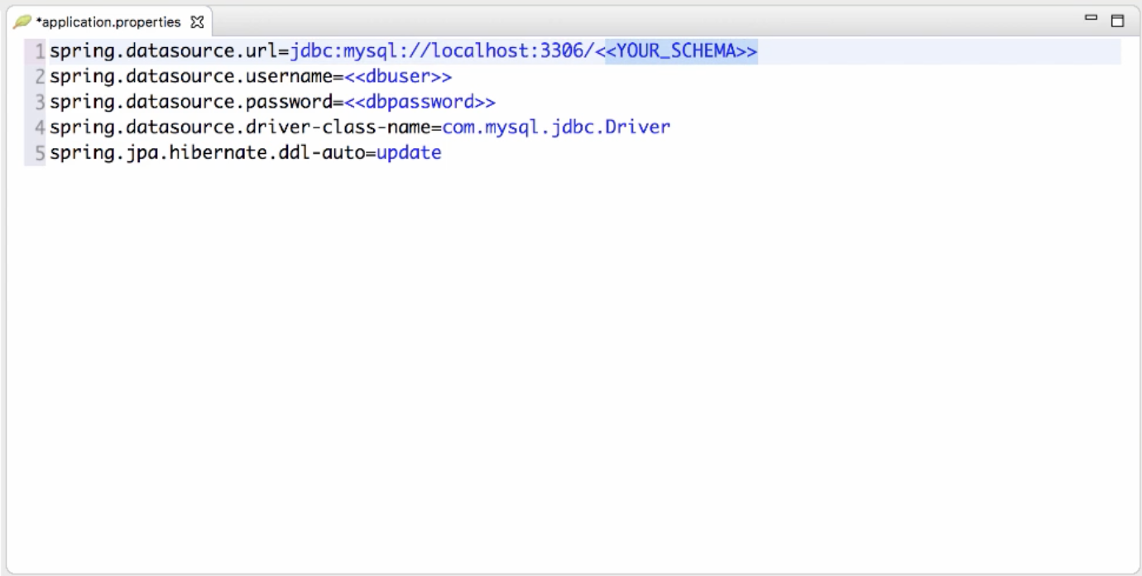

#5: Open the program MAMP (make sure you have the right port and the server is running).

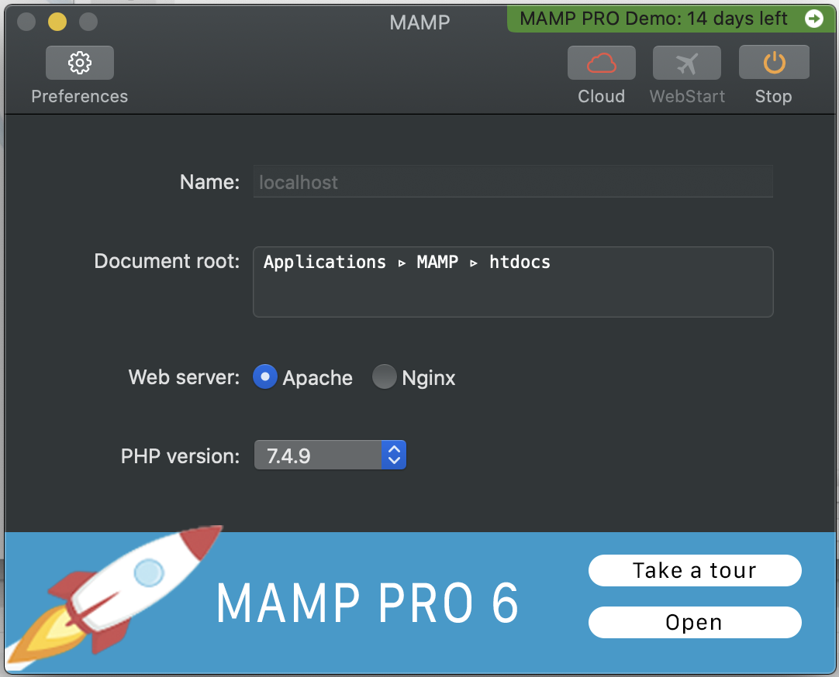

#6: Now we can work with WORKBENCH (SELECT 3306 port – *SUBJECT TO CHANGE*)

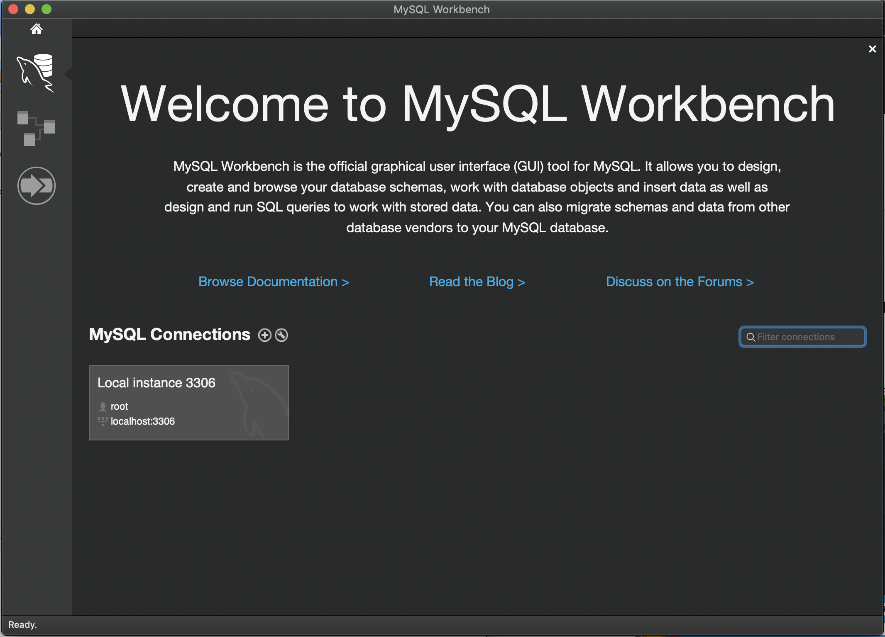

#7: Create a new schema for the project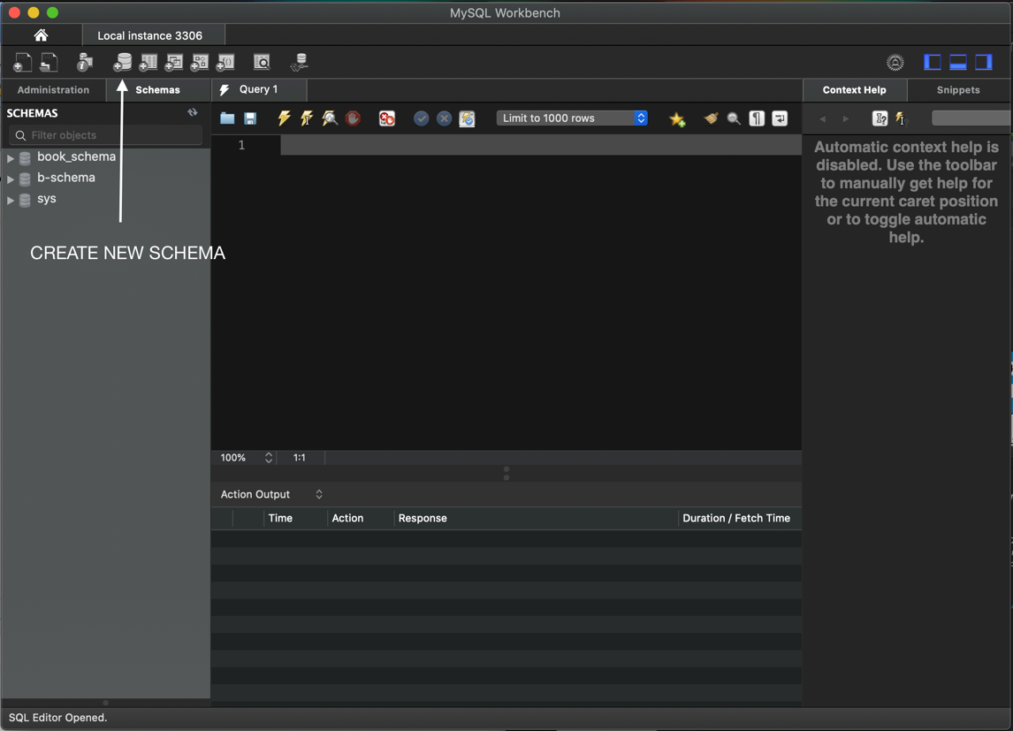

#8: Name the schema and se Character Set to utf8. (hit: APPLY x 2)

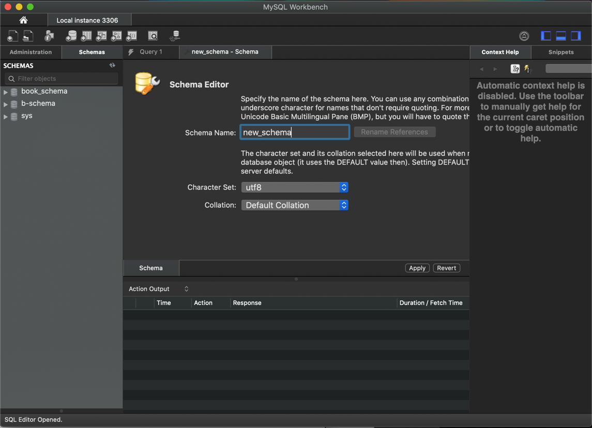

#9: Refresh the WORKBENCH

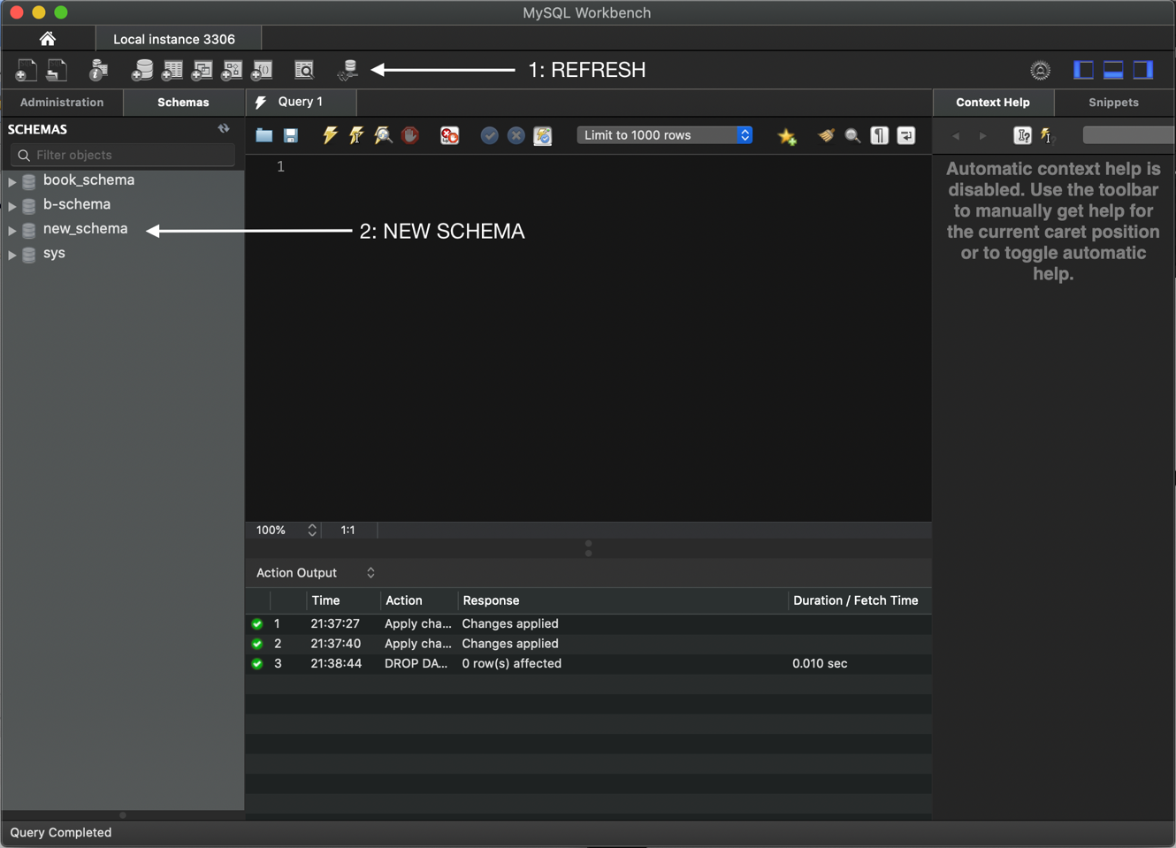

#10: Go BACK to Spring Tool Suite

Go to

📂 src/main/java

(Create Package in com.codingdojo.mvc)

(Create the package)

com.codingdojo.mvc.models

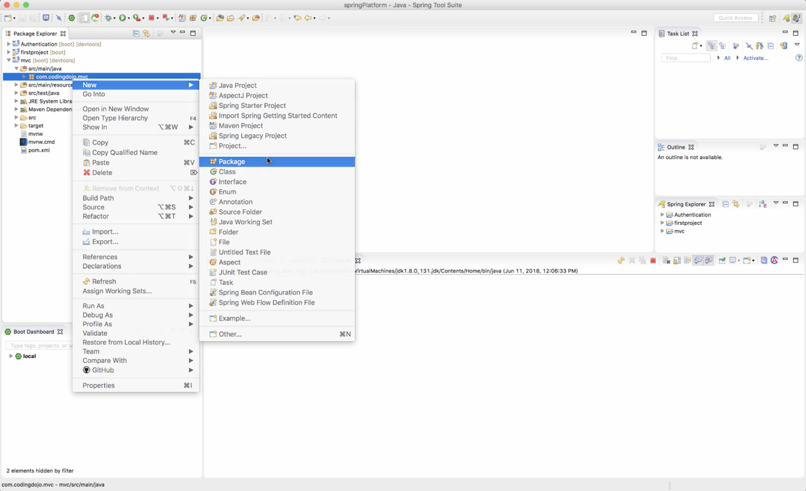

#11: Create Class(s) in the Package you created above.

(com.codingdojo.mvc.models)

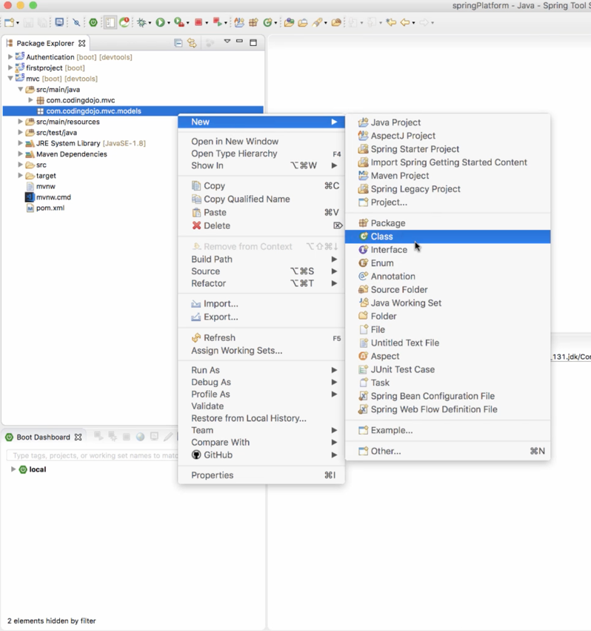

#12: Add this to the Class File you just created

(Make sure the necessary IMPORTS have been established)

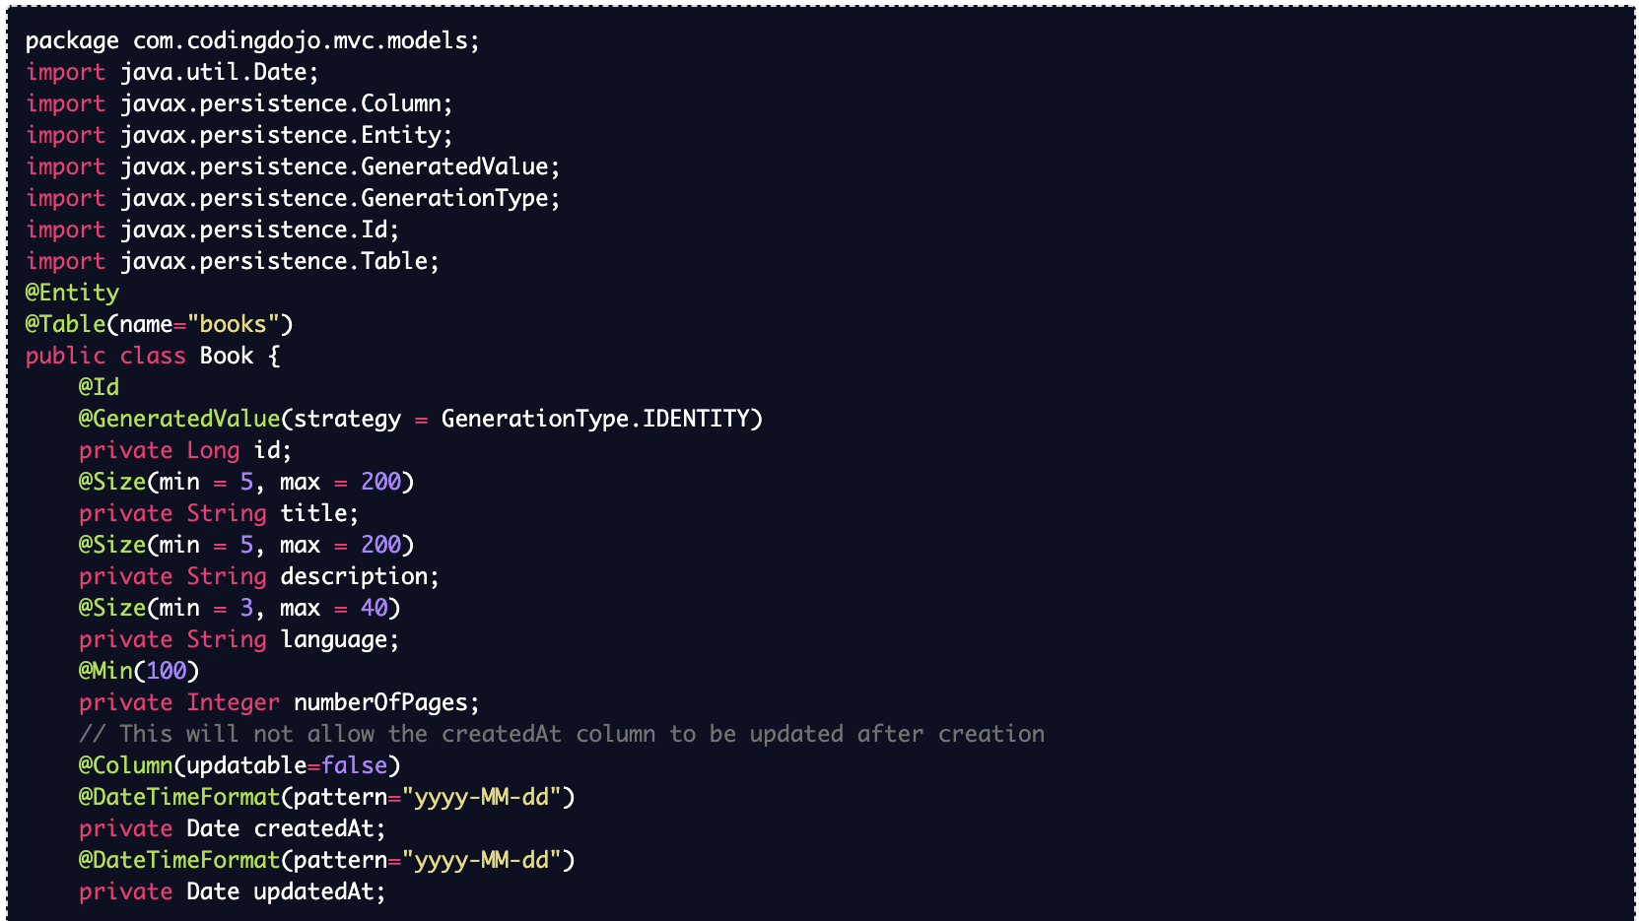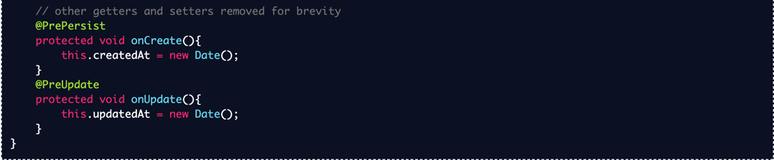

#13: Now Add Constructor

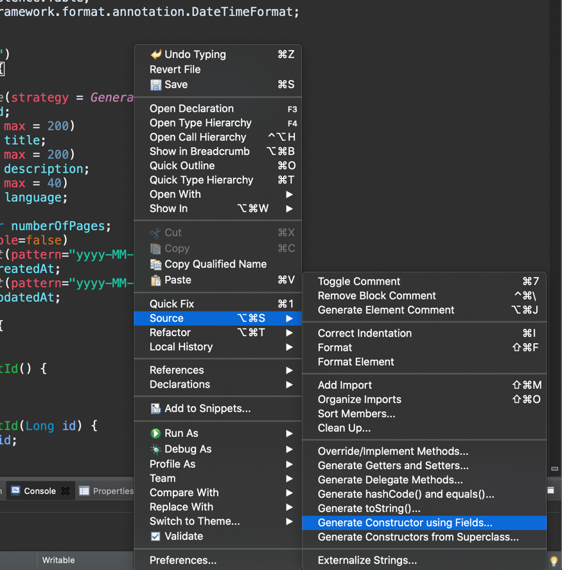

#14: Deselect All

(Once created remove the SUPER class)

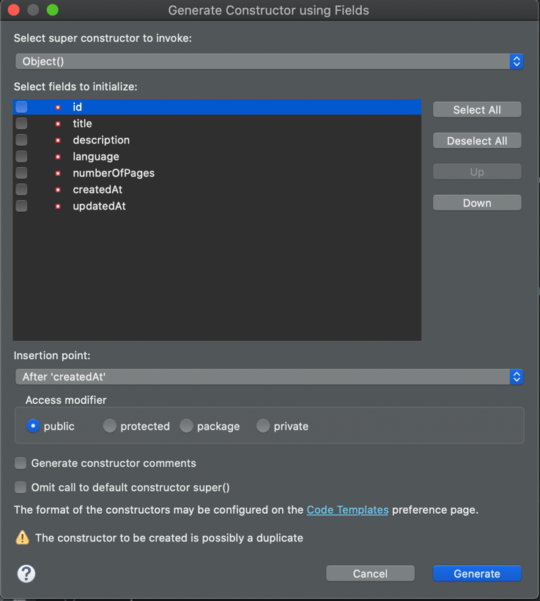

#15: Generate Getters and the Setters

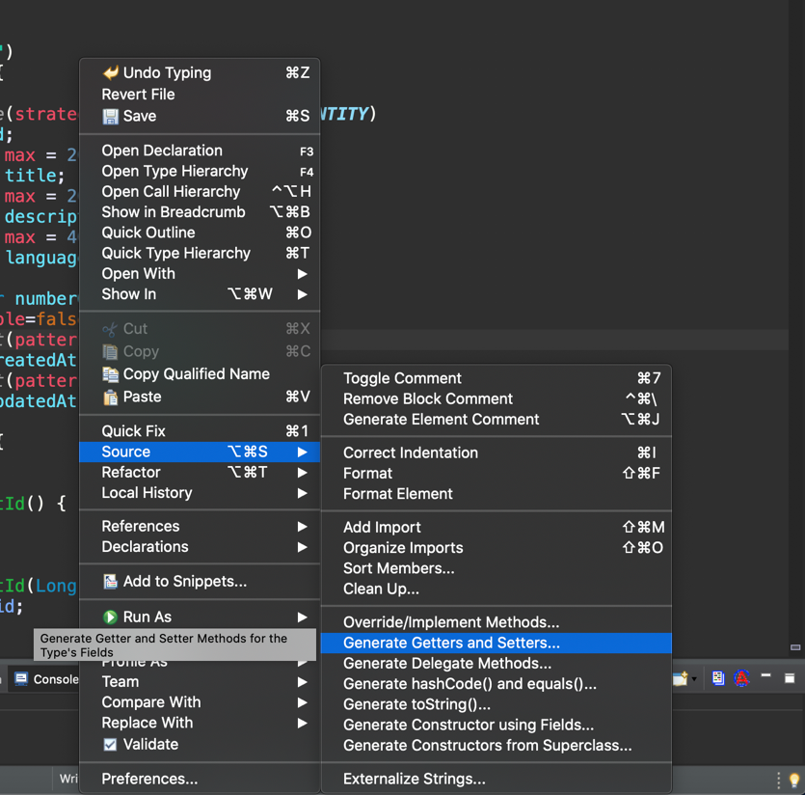

#16: We need to create a repository

First thing we need to do is create a package

(com.codingdojo.mvc.repositories)

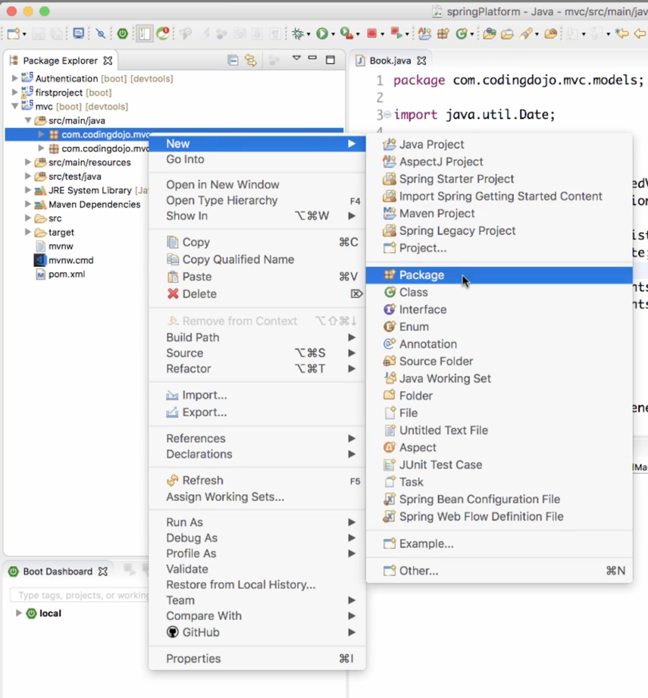

#17: Now we need to create an Interface

Make sure you name after the constructor followed by Repository

EX:(BookRepository)

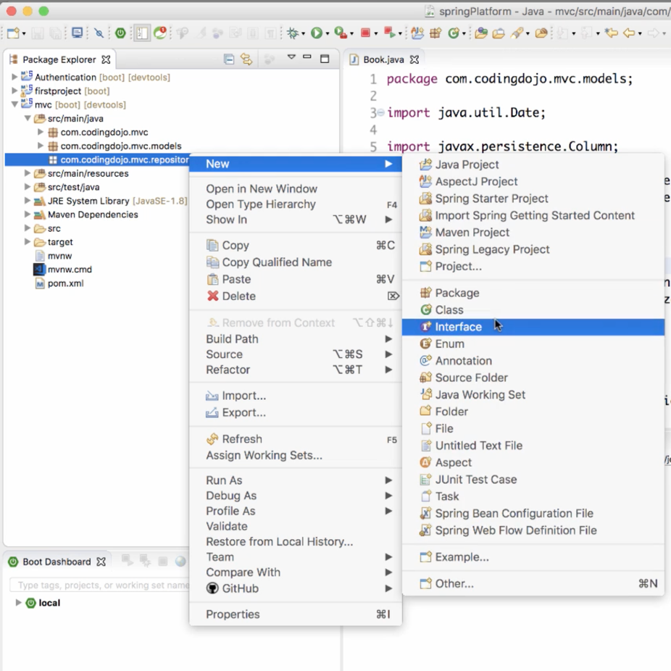

#18: Your Interface file should look similar to this

(NOTE: this is an example from MVC assignment)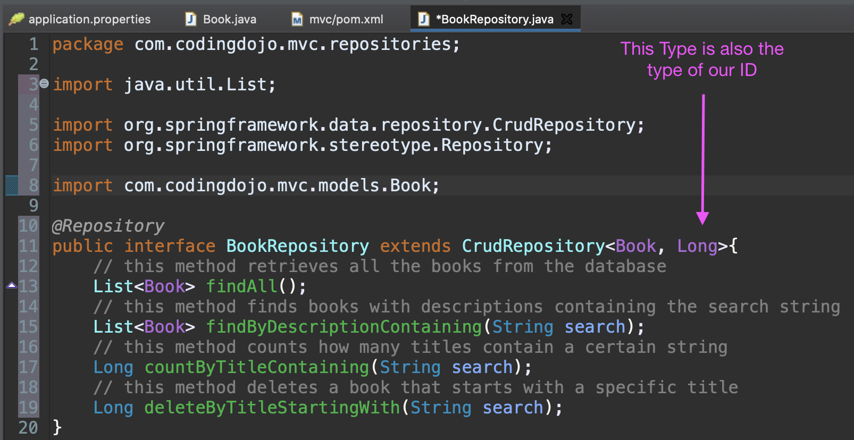

#19: Now we need to create another package

(com.codingdojo.mvc.services)

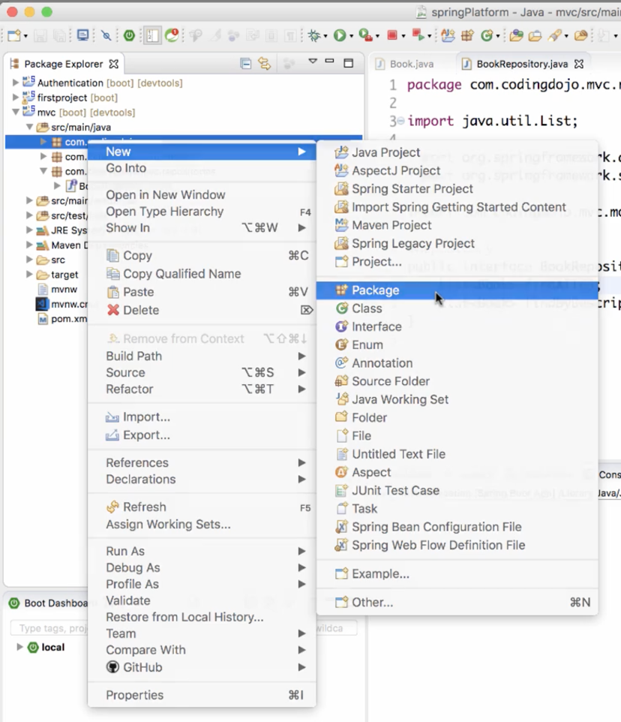

#20: The next thing is to create a Class

Make sure you name after the constructor followed by service

(BookService)

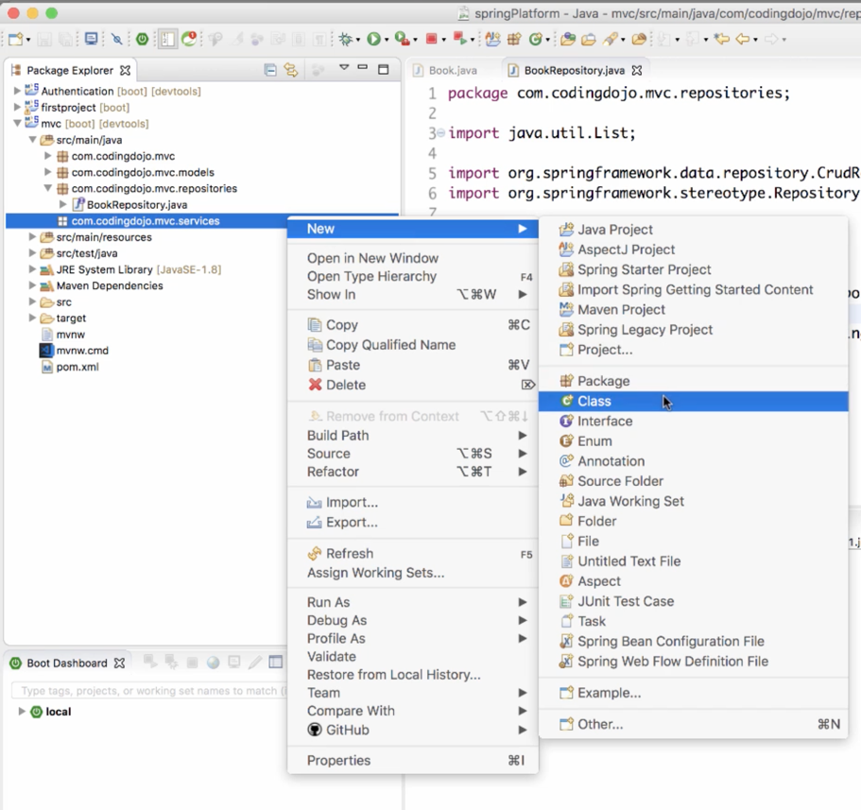

#21: Set up the Service

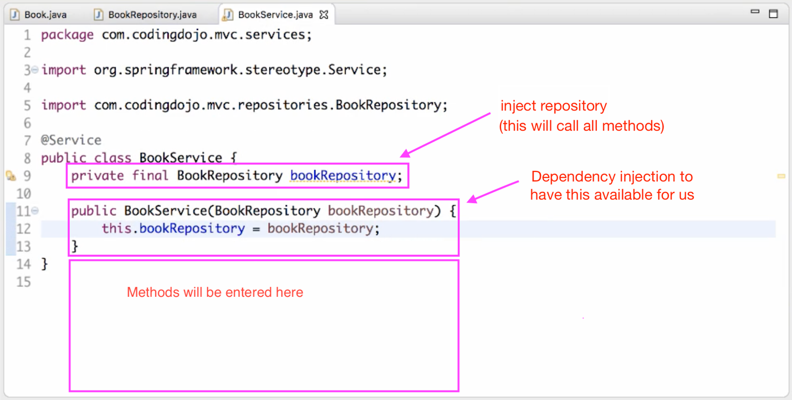

#22: Here are some examples methods to add above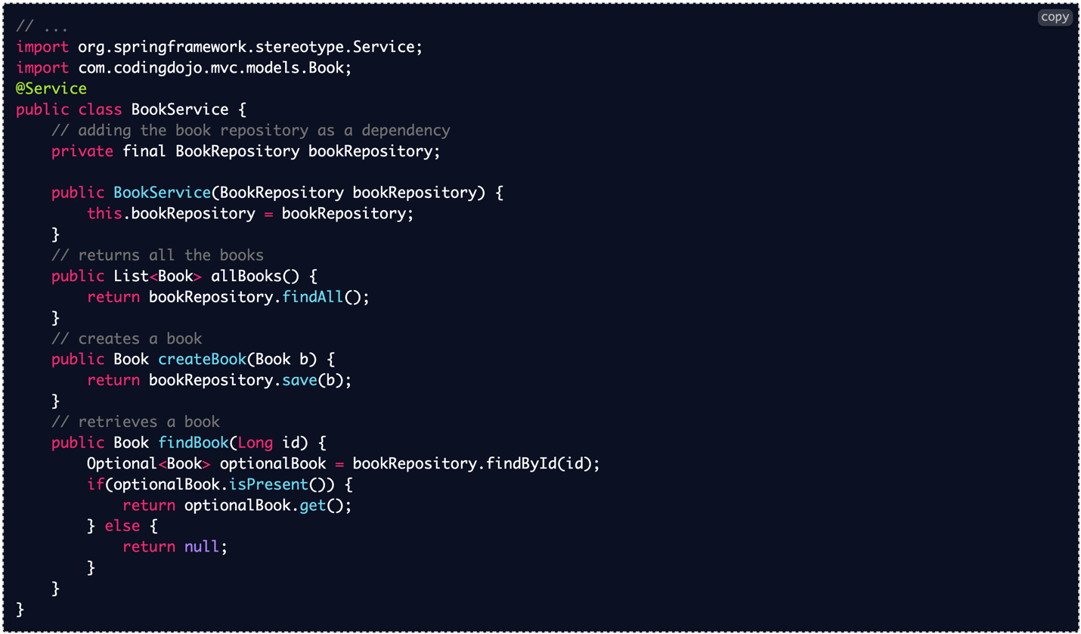

#23: Create a package for the controllers

Make sure you name after the constructor followed by controllers

(com.codingdojo.mvc.controllers)



#24: Inside of that package create a new class

Give it a name ending in Api

(BooksApi)

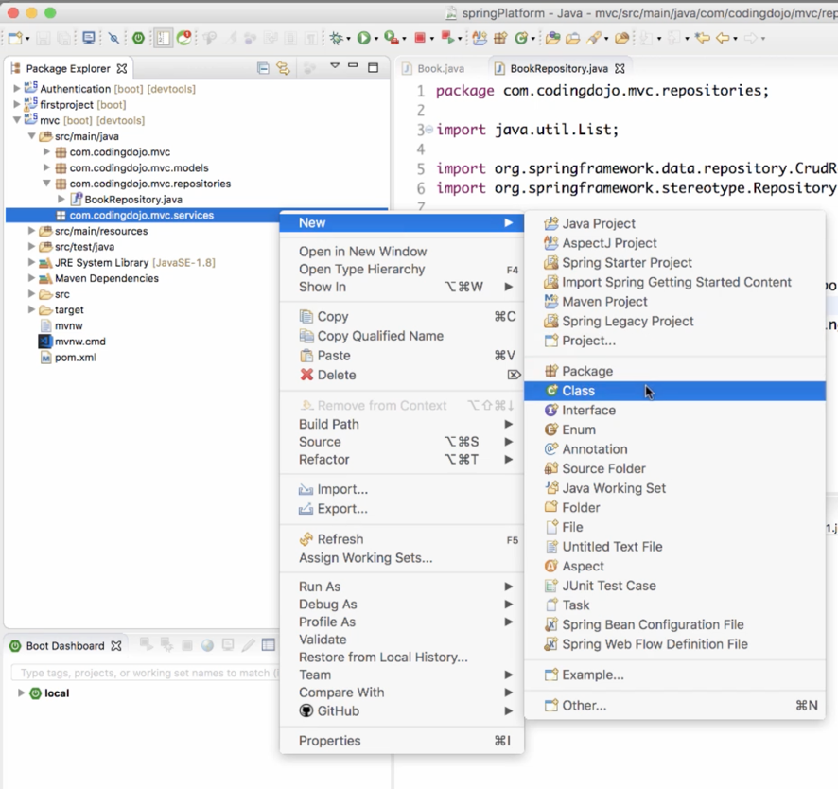

#25: Your BookApi should look similar to this

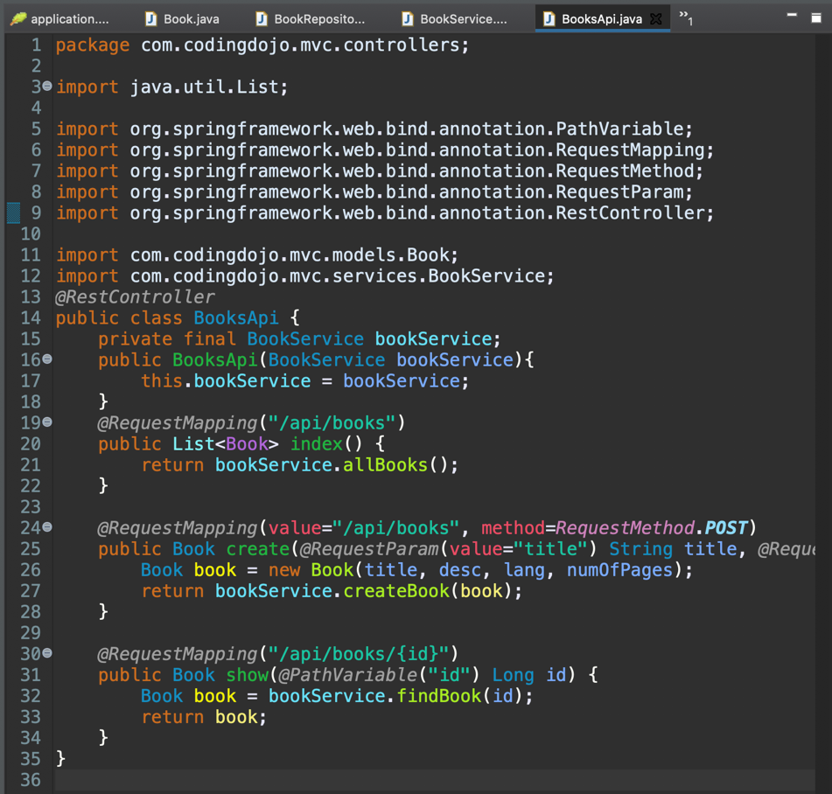

#26: Now that the API file is set-up

We need add another Constructor

Use the Auto generation by right clicking and going down to Source

